

Savitribai Phule Pune University



Project Report

on

***“Aluminum-Air Battery:***

***Innovation in Energy Storage”***

*Submitted By*

Krrishh Shirbhaiye (72285338G)

*Carried out at*

AISSMS-COE

*Under The Guidance of*

Internal Guide

Dr. S. B. Ghugare

Assistant Professor

DEPARTMENT OF CHEMICAL ENGINEERING

2024-2025



**DEPARTMENT OF CHEMICAL ENGINEERING**

***CERTIFICATE***

# This is to certify that, Krrishh Shirbhaiye of B.E. Chemical Engineering has completed Project Phase-I, “Aluminum Air Battery” towards the partial fulfillment of the requirements of the Degree of Engineering course under the Savitribai Phule Pune 0University, Pune during the academic year 2024-25.

Dr. S. B. Ghugare Dr. M. Y. Naniwadekar

*Project* *Guide*  HOD Chemical Engg

**ACKNOWLEDGEMENT**

The successful completion of any work would be incomplete unless we mention the names of people whose guidance and encouragement served as beacon light and crowned our effort with success

We express sincere thanks to our internal guide, Dr. S. B. Ghugare, who motivated, guided, and encouraged us at every step. Their guidance was of the utmost importance.

We also take this opportunity to express our gratitude to **Dr.M.Y. Naniwadekar**, Head, of the Department of Chemical Engineering, for constant support throughout project work.

We also thank **Dr. D. S. Bormane, Principal,** for providing us with an academic environment that nurtured our practical skills.

We would like to thank our beloved parents and other family members whose constant love, support, and encouragement have been the main source for whoever we are and it will continue everlasting.

Krrishh Shirbhaiye.

**Contents**

|  |  |  |  |
| --- | --- | --- | --- |
| **Chapter Number** | | **Description** | **Page Number** |
| **1** |  | Introduction**.** | 8 |
| 1.1 | Importance of the Subject. | 9 |
| 1.2 | Past Present & Future. | 10 |
| 1.3 | Outline of the Whole Report. | 11 |
| **2** |  | Literature Survey. | 13 |
| 2.1 | Comparison of different types of Batteries | 14 |
| **3** |  | Why Innovation In Energy Storage? | 16 |
| 3.1 | Mechanism of Aluminum-Air Battery. | 17 |
| 3.2 | Components Used in Making. | 18 |
| 3.3 | Calculations. | 19 |
| **4** |  | Ongoing Research & Future Scope. | 26 |
| **5** |  | References. | 27 |

**List of Figures**

|  |  |  |
| --- | --- | --- |
| **Fig. Number** | **Description** | **Page Number** |
| **Fig.1** | Aluminum Air Battery. | 11 |
| **Fig.2** | Components of Aluminum Air Battery. | 12 |
| **Fig.3** | Understanding Lithium-Ion Battery. | 15 |
| **Fig.4** | Understanding Lead-Acid Battery. | 15 |
| **Fig.5** | Understanding Aluminum-Air Battery | 15 |
| **Fig.6** | Current Output Analysis. | 21 |
| **Fig.7** | Pie-Chart of Material Balance. | 23 |

**List of Tables**

|  |  |  |
| --- | --- | --- |
| **Table Number** | **Description** | **Page Number** |
| **1** | Comparison with other Batteries. | 14 |
| **2** | Summary of Calculations. | 25 |

**ABSTRACT**

Aluminum-air batteries are a promising energy storage technology characterized by high energy density and lightweight structure. Utilizing aluminum as an anode and oxygen from ambient air as a cathode, these batteries produce electricity through a redox reaction, generating aluminum hydroxide as a byproduct. The abundance and recyclability of aluminum, coupled with the simplicity of oxygen sourcing, make this system both cost-effective and environmentally friendly. While aluminum-air batteries are known for high theoretical energy capacities, challenges such as electrode degradation and limited rechargeability impede widespread commercialization. Ongoing research is focused on optimizing electrolyte formulations, enhancing air cathode stability, and addressing the recyclability of byproducts to unlock the potential of aluminum-air batteries in applications ranging from electric vehicles to backup power sources.

**Chapter 1**

**INTRODUCTION**

Aluminum-air batteries are a metal-air electrochemical cell that utilizes aluminum as the anode and oxygen from the air as the cathode. These batteries are recognized for their high energy density and lightweight characteristics, making them particularly appealing for electric vehicles (EVs) applications, portable electronics, and military equipment. The fundamental electrochemical reaction in aluminum-air batteries involves the oxidation of aluminum in the presence of oxygen, generating electricity and aluminum hydroxide as a byproduct.

One of the primary advantages of aluminum-air batteries is their energy density, which can be significantly higher than that of conventional lithium-ion batteries. This characteristic stems from aluminum's high specific energy and ability to utilize atmospheric oxygen as a reactant, which reduces the battery system's weight. Additionally, aluminum is an abundant material, making these batteries more sustainable and cost-effective compared to those that rely on rare metals.

Despite their promising attributes, aluminum-air batteries face several challenges, including limited rechargeability and issues related to the stability of the electrolyte and the formation of byproducts. Current research is focused on overcoming these limitations through advancements in materials science, electrolyte formulations, and innovative design approaches.

* 1. **Importance of the subject:**

Aluminum-air batteries are gaining attention due to their high energy density and lightweight profile, making them particularly valuable in fields requiring efficient energy storage, like electric vehicles and portable power systems. Aluminum is one of the most abundant elements on Earth, which makes these batteries potentially more affordable and less resource-intensive than alternatives using scarce metals. Additionally, aluminum-air batteries rely on oxygen from the air as a cathode, which reduces the need for heavy materials and increases their potential energy output per unit of weight.

This technology stands out not only for its performance potential but also for its environmental benefits, as aluminum can be recycled and does not involve toxic heavy metals common in other batteries. While the technology faces challenges like limited rechargeability and electrolyte degradation, advances in material science are working to make aluminum-air batteries a competitive choice in the growing demand for sustainable energy solutions.

* 1. **Past, present, and future:**

**Past:**

The concept of aluminum-air batteries dates back to the 1960s when researchers first explored aluminum's potential as an energy source. Early designs focused on the high energy density achievable by using aluminum as an anode and atmospheric oxygen as the cathode. However, challenges with electrolyte stability, corrosion, and limited rechargeability hindered initial efforts. While the technology offered promise, practical limitations kept it largely in the research phase, with only niche applications in military and emergency power systems.

**Present:**

Recent advances in materials science and electrochemistry have revived interest in aluminum-air batteries. Today, they are recognized for their potential as a lightweight and cost-effective energy source, particularly in electric vehicles and portable electronics. Current research focuses on improving electrolyte composition, enhancing the air cathode, and managing aluminum hydroxide byproducts to increase efficiency and lifespan. Companies are beginning to explore aluminum air as a complementary power source in hybrid systems, although fully commercialized options remain limited due to the challenges of rechargeability and maintenance.

**Future:**

The future of aluminum-air batteries holds significant promise if ongoing research can resolve the key technical issues. Scientists are actively working on developing new electrolytes that minimize corrosion and allow for partial rechargeability, which would make the technology more practical for a wider range of applications. There is hope that, in the next decade, aluminum-air batteries could become viable for electric vehicles, grid storage, and even emergency power. Suppose breakthroughs in efficiency, durability, and recyclability continue. In that case, aluminum-air batteries may play a critical role in the transition to sustainable energy by offering a scalable, low-cost solution for various energy-intensive needs

* 1. **Outline of the whole report**

Aluminum-air batteries offer a promising alternative to traditional batteries with their high energy density and cost-effectiveness.

They face challenges, particularly with rechargeability and corrosion, but ongoing research aims to overcome these obstacles.

With further development, aluminum-air batteries could play a significant role in various industries, from electric vehicles to backup power.

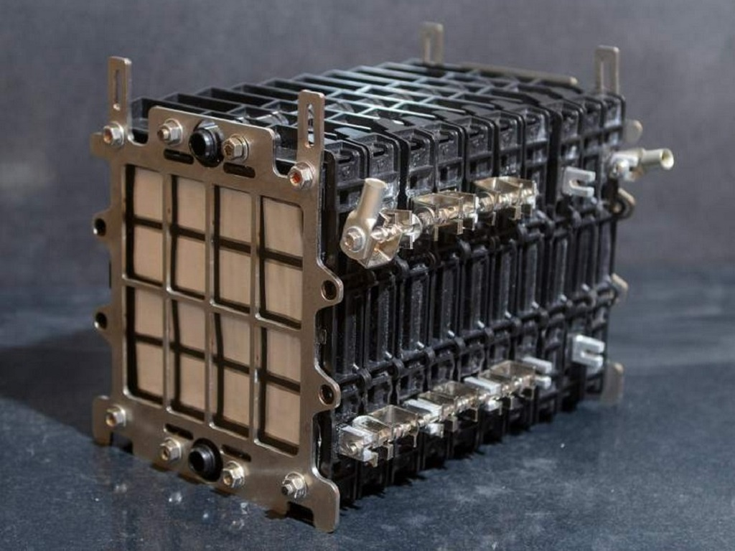

Fig.1 Aluminum Air Battery

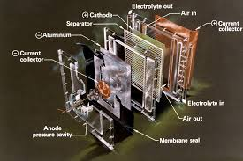

Fig.2 Components of Aluminum Air

**Chapter 2**

**LITERATURE SURVEY**

Aluminum-air batteries (AABs) are gaining attention as a viable alternative for energy storage and electric vehicle applications due to their high energy density and lightweight nature. These batteries utilize aluminum as the anode and oxygen from the air as the cathode, generating electricity through an electrochemical reaction

The core reaction involves the oxidation of aluminum to form aluminum hydroxide or aluminum oxide, coupled with oxygen reduction in the presence of an electrolyte. The overall reaction can summarize this process:

4𝐴𝑙+3𝑂2+6𝐻2𝑂→4𝐴𝑙(𝑂𝐻)3

​AABs can theoretically achieve energy densities of around 1300 Wh/kg, significantly higher than traditional lithium-ion batteries. However, the practical energy output is often lower due to factors like electrolyte degradation and aluminum passivation, which inhibits further reaction. Research is ongoing to enhance efficiency and cycle life, focusing on optimizing the electrolyte composition and improving the design of the air cathode. Aluminum-air batteries hold great potential for sustainable energy storage and automotive applications. Ongoing research is essential to overcome current limitations, particularly regarding rechargeability and corrosion resistance. Continued advancements could lead to practical implementations in various sectors, positioning AABs as a key player in the future of energy storage technology.

**2.1 Comparison of different types of Batteries:**

|  |  |  |
| --- | --- | --- |
| **Aluminum-air Battery** | **Lead-Acid**  **Battery** | **Lithium-Ion Battery** |
| Very high energy density; more energy per kilogram, making it lighter for high-energy applications | Low energy density, making it bulkier for the amount of energy it stores. | High energy density; stores a lot of energy in a compact, lightweight form. |
| Not typically rechargeable; the aluminum anode degrades and needs replacing, though new designs are exploring rechargeability. | Rechargeable; widely used in applications requiring frequent recharges, like car batteries. | Easily rechargeable, making it ideal for electronics and electric vehicles. |
| Low, as it needs replacement once aluminum is consumed; not designed for long-term cycling. | Moderate cycle life but reliable for stationary and automotive applications. | High cycle life; can handle many charge and discharge cycles. |
| Generally eco-friendly, as it produces mostly non-toxic waste, and aluminum is recyclable. | Contains toxic lead, requiring special recycling and disposal processes to avoid contamination. | Better than lead-acid in terms of toxicity, but lithium mining and disposal raise environmental concerns. |
| Expensive due to the cost of aluminum and production constraints | Lower cost; widely produced and affordable, especially for low-power applications. | Moderate to high cost, especially for high-performance cells in EVs and electronics. |
| Lightweight for the energy it provides, great for applications where weight matters | Heavy and bulky; not ideal for applications where weight is critical. | Lightweight and compact, making it perfect for mobile devices and electric vehicles. |
| Long shelf life due to stable aluminum, making it good for storage without energy loss. | Moderate shelf life; lead-acid batteries self-discharge faster than others, especially in heat. | Longer shelf life with low self-discharge, especially in cool conditions. |

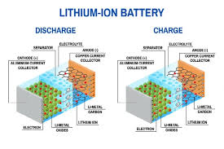

Fig.3 Understanding Lithium-Ion Battery.

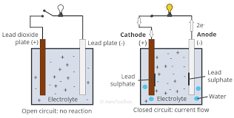

Fig.4 Understanding Lead-Acid Battery.

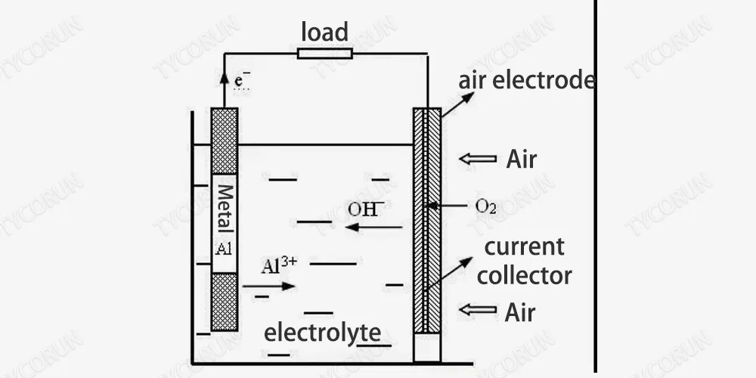

Fig.5 Understanding Aluminum-Air Battery.

**Chapter 3**

**Why Innovation in Energy Storage?**

The title **"Aluminum-Air Battery: Innovation in Energy Storage"** captures the unique promise of aluminum-air batteries in the evolving field of energy storage, which has a massive impact on transportation, electronics, and sustainable energy solutions. This technology stands out because it offers a high energy density — meaning it can store large amounts of energy relative to its weight. This advantage makes it especially promising for applications like electric vehicles, where lightweight and long-lasting batteries are highly valued.

Unlike traditional batteries like lead-acid or even lithium-ion, aluminum-air batteries harness the natural oxidation of aluminum when exposed to oxygen in the air. This design delivers impressive energy output and presents an environmentally friendly option, as aluminum is abundant and easily recyclable. Although current aluminum-air batteries are typically single-use, ongoing research explores ways to make them rechargeable, further enhancing their practicality and eco-friendliness.

So, calling this technology an "innovation in energy storage" is fitting because it addresses modern needs for high-power, sustainable, and potentially more affordable energy solutions, showing potential for revolutionizing industries that rely on portable or backup power.

**3.1 Mechanism of Aluminum-Air Battery:**

**Anode Reaction:** Aluminum (Al) reacts with hydroxide ions (OH⁻) to form aluminum hydroxide (Al(OH)₃) and release electrons.

**Cathode Reaction:** Oxygen from the air reacts with water to form hydroxide ions (OH⁻) while accepting electrons.

**Overall Reaction:**

4Al+3O2+6H2O→4Al(OH)3+Electricity(2.71V)

**Illustration of the battery structure:**

**Anode:** Aluminum plate.

**Electrolyte:** Aqueous solution typically contains a strong base like potassium hydroxide (KOH).

**Cathode:** Porous air electrode.

**3.2 Components used:**

Components that are used to make an Aluminum-Air Battery at home are as follows:

1. **Aluminum Foil or Aluminum Sheet**: This serves as the anode (negative electrode) of the battery.
2. **container: A**glass container will house your battery components. Ensure it can withstand the electrolyte without leaking.
3. **Separator:​** (like a piece of cloth or paper towel) can be used to separate the anode and cathode while allowing the electrolyte to permeate.
4. **Wires and Connector​:** to connect the battery to any devices you wish to power. Copper wires are usually best for conductivity.
   1. **Calculations:**

**Assumptions & Requirements:**

Mass of Aluminum = 1kg

Electrolyte = NaOH (20% by Weight)

Operating Temperature = 300C

Faraday’s Constant = 96485C/mol

Molar Mass of Aluminum = 27g/mol

Standard Energy Density = 8.1KWH/kg

* **Power Output Calculations.**

**Theoretical Current Calculation.**

As Aluminum donates 3 electrons per atom,

Theoretical Output:

Mass of Aluminum=1kg (1000g)

using molar mass; mol of Al = 1000g/27g/mol

= 37.04 mol

So, the theoretical output of the battery with the assumed conditions should be 37.04 mol

Total Charge Available (C): 3 x Faraday’s Constant.

Q per mole = 3 x 96485C/mol.

= 289455C/mol.

Therefore, the theoretical charge for 37.04mol will be;

37.04mol x 289455C/mol.

Qtotal= 10728513Cal.

Theoretical Current Output (A):

I theoretical = Qtotal/time (s)

= 10728513Cal/ 36000s

= 298A

**Actual Current Output:**

In practice, the system experiences several losses which are;

Ohmic resistance in the electrolyte.

Parasitic reactions (Formation of aluminum hydroxides reduces efficiency).

Operating conditions (Temperature, electrolyte conditions, etc.)

Assume the practical efficiency is around 55% (Due to losses)

Therefore,

Iactual = Itheoretical x 0.55

= 298 x 0.55

= 164 A

Therefore, the actual current output of the battery is 164A (assuming 55% efficiency)

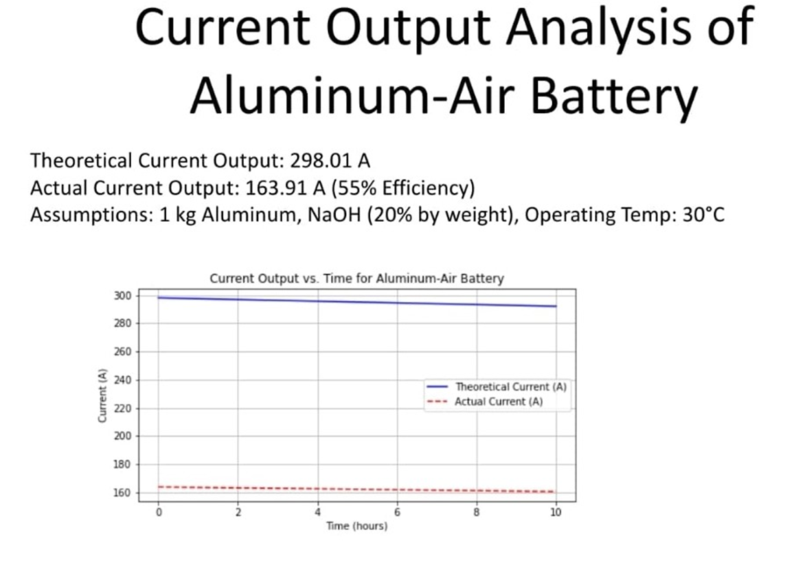

Fig.6 Current Output Analysis.

* **Material Balance.**

**Reaction:** 4Al+3O2+6H2O→4Al(OH)3+Electricity(2.71V).

Molar Mass of Al = 27g/mol.

Molar Mass of 4Al(OH)3 = 78g/mol.

Now,

Moles of Al = 1000g/27g/mol

= 37.04g

Now,

4 moles of Al reacts with 3 moles of O2.

Therefore, moles of oxygen = 3/4 x 37.04

= 27.78mol

Molar mass of oxygen = 32g/mol

Now,

Mass of Oxygen = 27.78 x 32

= 888.96g

= 0.89kg

Now,

For every 4 moles of Al, 6 moles of H2O are consumed.

the moles of water required are:

Moles of H2​O= 46​ x 37.04

=55.56mol.

Molar mass of H2​O = 18 g/mol.

The total mass of water used is:

Mass of H2​O=55.56×18

=1000g

=1kg

Now,

4moles of aluminum produce 4 moles of aluminum hydroxide

Thus, the total moles of aluminum hydroxide formed are:

Moles of Al(OH)3 = 37.04mol

The corresponding mass of aluminum hydroxide is:

Mass of Al(OH)3 = 37.04 x 78

= 2889.12g

= 2.89Kg

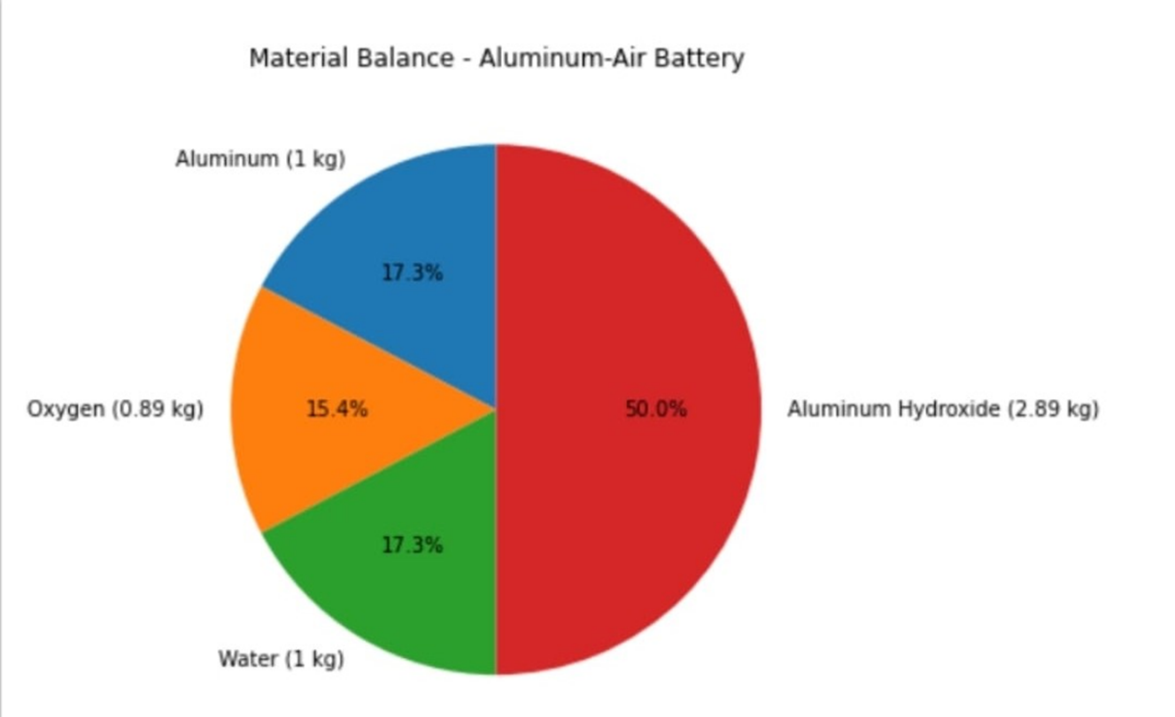

Fig.7 Pie-chart for Material Balance.

* **Energy Balance.**

**Step 1: Theoretical Energy Output:**

The theoretical energy density of aluminum is 8.1 kWh/kg.

For 1 kg of aluminum: Theoretical Energy =8.1kWh

=29160kJ

**Step 2: Practical Energy Output:**

Considering 55% efficiency due to losses (Ohmic, parasitic reactions, etc)

Practical Energy =0.55×8.1kWh

=4.455kWh

=16038kJ

**Step 3: Heat Losses**:

The heat lost due to inefficiencies is the difference between theoretical and practical energy:

Heat Lost =29160kJ−16038kJ

=13122kJ

* **Summary of Calculations.**

|  |  |  |
| --- | --- | --- |
| **Power Output:** | **Material Balance:** | **Energy Balance:** |
| Theoretical Current Output: 298 A | Aluminum consumed: 1 kg | Theoretical Energy Output: 29160 kJ(8.1kWh) |
| Actual Current Output: 164 A (assuming 55% efficiency). | Oxygen consumed: 0.89 kg | Practical Energy Output:16038 kJ(4.455kWh) |
|  | Water consumed: 1 kg | Heat Lost:13122kJ |
|  | Aluminum hydroxide produced: 2.89 kg |  |

**Chapter 4**

**ONGOING RESEARCH &FUTURE SCOPE**

Aluminum-air batteries are an exciting area of research with vast potential, particularly for electric vehicles (EVs) and grid storage. These batteries boast a high energy density—up to ten times greater than lithium-ion batteries—and are both lightweight and relatively inexpensive, making them ideal for long-range EVs and portable devices. Aluminum's abundance and non-toxic nature enhance its appeal as a sustainable option.

In recent years, research on aluminum-air battery technology has gained momentum in India, particularly due to its potential benefits for electric vehicles (EVs) and national energy independence. Aluminum-air batteries, developed by Israeli company Phinergy, generate power through a reaction between aluminum and oxygen. This approach allows for higher energy density than traditional lithium-ion batteries, extending vehicle range significantly and enabling faster “refueling” by swapping the aluminum plates rather than recharging. This makes the technology particularly attractive for India, which is rich in aluminum resources but imports most of its lithium​.

To advance this technology locally, Indian Oil Corporation (IOC) formed a joint venture with Phinergy, partnering with Hindalco Industries to support R&D, production, and aluminum recycling. Hindalco’s involvement is key, as the company provides essential infrastructure for manufacturing and recycling aluminum plates. Currently, automotive giants like Mahindra, Tata Motors, and Maruti Suzuki are testing these batteries to gauge their viability for commercial use.

This shift toward aluminum-air batteries aligns with India’s “Atmanirbhar Bharat” (self-reliant India) initiative, aiming to reduce dependence on imported lithium while creating a more sustainable EV infrastructure. Additionally, aluminum-air battery technology is considered environmentally friendly, as it involves fewer hazardous materials than lithium-ion batteries. With its low emissions profile and the prospect of creating local manufacturing jobs, aluminum-air technology holds promise as an essential part of India’s transition to clean energy and reduced fossil fuel dependence​.

**REFERENCES**

[1] "Review of aluminum-air battery: Basic principles, challenges, and future." Journal of Power Sources, 395, 300-310.Link to article: https://www.sciencedirect.com/science/article/abs/pii/S0378775317312890

[2] "Advances in air cathode materials for aluminum-air batteries." Electrochemical Acta, 299, 204-214. Link to article:

https://www.sciencedirect.com/science/article/abs/pii/S0013468619306400

[3] Lefebvre, D., et al. (2016). "Corrosion inhibition in alkaline electrolytes for aluminum-air batteries." Corrosion Science, 107, 84-92. Link to article:

https://www.sciencedirect.com/science/article/abs/pii/S0010935815300633

[4] Pan, Z., et al. (2022). "Aluminum-air battery applications in electric vehicles: Challenges and outlook." Energy Reports, 8, 1021-1035. Link to article:

https://www.sciencedirect.com/science/article/pii/S2352484722001948

[5] Martinez, E., et al. (2020). "Environmental impact assessment of aluminum-air batteries." Sustainable Energy Technologies and Assessments, 39, 100655. Link https://www.sciencedirect.com/science/article/pii/S2213138820301242

[6] Aluminum Air Battery: How Do They Work? Link to Article:

<https://www.slideshare.net/slideshow/aluminum-air-battery-how-do-they-work-plus-diy/238948572>

[7] Real-World Testing of Aluminum-Air EV Battery Underway. Link to Article:

<https://www.motorbeam.com/real-world-testing-of-aluminium-air-ev-battery-underway/>

**[8] Industrial Battery Comparison:**

https://r5.ieee.org/houston/wp-content/uploads/sites/32/2020/03/Battery-Technology-Comparison-IEEE-2020.pdf

**[9] Comparison of commercial battery types (Wikipedia):**

https://en.wikipedia.org/wiki/Comparison_of_commercial_battery_types

**[10] Power Sonic's Guide:**

https://www.power-sonic.com/blog/lithium-vs-lead-acid-batteries/

**[11] Cloud Energy Blog: Expert Insights on Lithium Battery: Lithium-Ion Battery vs Lead Acid Battery: A Comprehensive Comparison:**

https://www.cloudnewenergy.com/blogs-detail/lithium-ion-battery-vs-lead-acid-battery

# [12] Lithium-ion vs. Lead-acid: Performance, Costs, and Durability:

<https://renewablesadvice.com/battery/lithium-ion-vs-lead-acid/>

**[13] Tycron Energy:**

<https://www.takomabattery.com/aluminum-air-battery-2/>

**[14] Aero Toolbox:**

<https://aerotoolbox.com/aircraft-lead-acid-battery/>

**[15] Ufine Blog:**

<https://www.ufinebattery.com/blog/how-does-a-lithium-ion-battery-work/>

**[16] Energy Connects:**

<https://www.energyconnects.com/news/renewables/2021/july/a-major-ev-battery-bet-for-india-is-on-aluminum-over-lithium/>

**[17] Autocar Professional:**

<https://www.autocarpro.in/news/indian-oils-aluminium-air-battery-manufacturing-jv-readies-itself-for-manufacturing-rollout--113826>

**[18] Hindustan Times Auto:**

<https://auto.hindustantimes.com/auto/electric-vehicles/how-locally-made-aluminum-air-batteries-may-be-big-boost-to-ev-adoption-in-india-41658221897220.html>